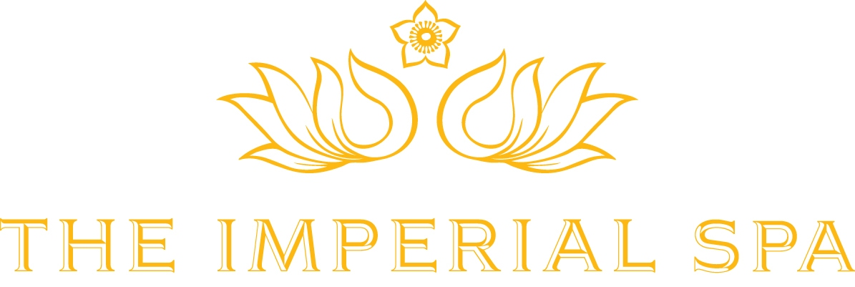

QUINTESSENTIALLY SUBLIME TEMPLE OF WELL-BEING “THE IMPERIAL SPA”

~Now open to non-residents, The Imperial Spa is a rejuvenation and wellness retreat in the city combining the ancient healings of Ayurveda and Yoga~

MARCH 2023: Nestled amidst the landscaped gardens, discover our temple of well-being and immerse in holistic wellness. Stepping into the timeless serenity of The Imperial Spa you know you have arrived in the lap of Gods. A world of rest, renewal and beauty awaits one at the spa, in search of calm. It drives inspiration from intricate Moroccan architecture, beautifully interwoven with Moghul and Indian motifs. Exquisite craftsmanship of tikri work embellishes the walls of this warren of arches. A quintessentially sublime haven for recuperative therapies in a naturally lit setting, the spa is a healing destination blending hand-picked signature rituals, bespoke oils and ancient traditions.

An indulgent spa day can be just what you need to rest and recuperate in tranquility. The Imperial Spa is designed for those seeking a digital detox in a silent retreat, to re-centre the mind, meditate and be mindful. An integrated health environment under the Mudra philosophy at the spa encapsulates India’s traditional healing systems, Ayurveda and Yoga. The wellness journey is conducted through our ten individual treatment rooms, each with a distinct character and elaborate wall motifs. The hamam style Hydro Therapy areas with Turkish elements and mild shades, exude quiet. The Moghul Suite at the spa is an architectural marvel and a private therapy abode for couples, pre-meditated with an en suite Steam, Sauna and Jacuzzi while The Kerala Suite is our traditional Ayurvedic centre opening up to wisdom and the oldest science of well-being, dissolving tensions and deepening breaths. The therapies here contain ‘miracle herbs’ like Moringa, Indian gooseberry, country mallow of the likes that protect and nourish skin while healing from within and can be combined with our resident Ayurvedic doctor’s consultation. These ambient and enchanting therapy suites & rooms along with the relaxation areas in soft white hues of marble inlay work emanate artistic elements, creating a meditative ambience.

The sense of indulgent downtime starts with our natural therapies formulated with warming and soothing oils made with naturally grown products, for a heartfelt embrace. These organic oils by Forest Essential have stimulating and aromatic properties, filled with a wealth of natural ingredients. Blending rare fragrant plants from India to lands far away, the oils offer that one drop of elixir for long-lasting effects and precious upliftment. These patented massage oils have an insightful process with each ingredient being painstakingly sourced to enrich your experience. The spa journey begins with a tailored ritual of choosing the base oil as per your skin type-sensitive, dry or oily and combining them with the essential ones, suiting your mood-woody, spicy or floral, savoured and approved by you at each step. From Nargis, to Oudh to Mandarin and Black pepper, the nine distinguished aromas, tend to cool or give warmth and work on sore muscles, relieve tension and improve blood circulation, helping to revive the skin and promote sleep. Custom-made for each individual’s spa sojourn, the oils are available for retail as well.

The novel therapeutic treatments at the spa meet individual health goals, to restore and rejuvenate. The hand-picked rituals in the menu include Imperial Iconic massage- the signature massage at The Imperial Spa incorporates a hot moisturizing candle massage from Meruva, South Africa, western healing, and balancing methods while Spa Together at The Moghul Suite is just perfect to unwind with someone special and share combined massages, within a private spa environment. Bringing harmony to the body and mind is Shirodhara which begins with a long soothing stroke massage to initiate relaxation. If you seek a hiatus to focus on physical and mental health, The Imperial Spa is your perfect destination.

The spa extends to the boutique Imperial Salons. Whether you want a complete style and colour change, a quick trim or top-to-toe beauty experience, the Ladies Salon has luxury global hair brands like pH, Italy and Moroccon Oil, Cuccio for luxury manicure and pedicure with Gemology, Paris and Skyndor facials– all under one roof. The sleek London-style Men’s area offers high quality grooming and Barber facilities. Friendly, tailored and pleasingly unpretentious, the Men’s Salon is best for contemporary cuts and innovative style techniques.

Spearheaded by Ms. Athini Kashe- Head of Spa, Salon and Wellness at The Imperial, New Delhi, The Imperial Spa is a blissful retreat within the heart of the city for Bleisure travelers. Integrating India’s age-old remedial systems like Ayurveda & Yoga with Global Spa therapies, the experience offered is personalized and exclusive. Combined with the boutique Salon spaces blending seamless beauty and luxury, we have many reasons for you to visit this sanctuary of well-being.”

